Table 27.-Westside Susitna River Management Unit chinook salmon escapement index counts, 1979-2002.
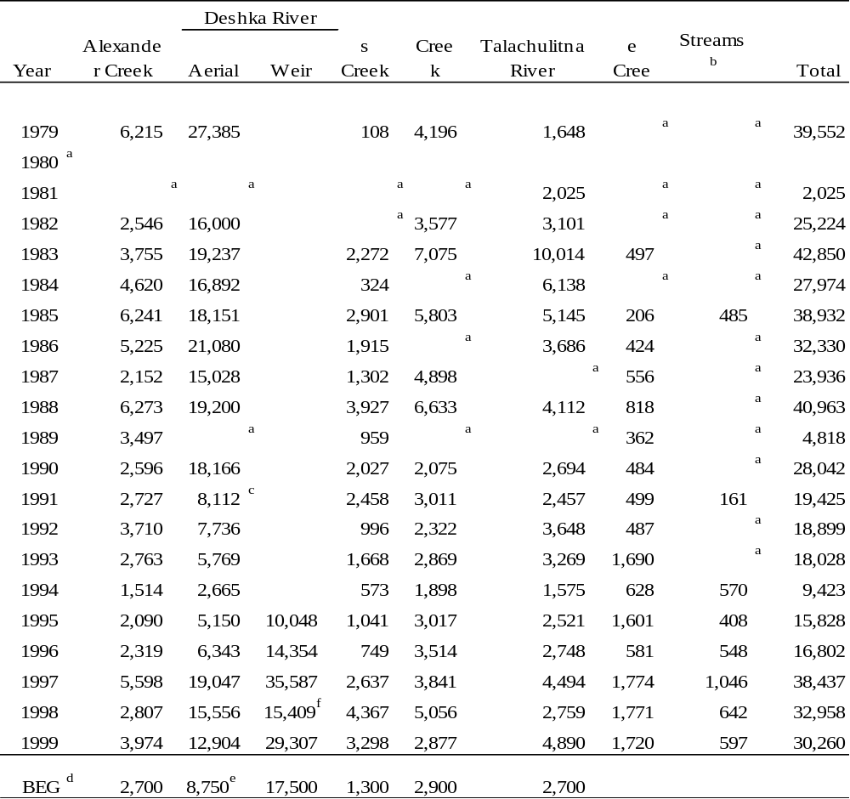
a No count conducted.
b May include Donkey Creek, Red Creek and other miscellaneous creeks.
c Low count due to timing, poor visibility or weather conditions.
^{d} Sustainable escapement goal.
^{e} Aerial escapement goal 1994-1998 was 11,200; revised for 1999 to 8,750; in 2002 aerial escapement goal was abolished.
^{f} During 1998 weir count represents only half the return. High water delayed construction until June 16.
Table 28.-Number of chinook salmon smolt stocked into the Willow Creek drainage from 1985-2002.
___________________________________________________________________
Total Number
Brood Release Smolt Coded wire Mean Release
Year Locationª Release Tagged Size Date
1983 Deception 101,256 8,152 18.0 6/13/85
1984 Deception 214,384 11,038 13.8 6/11-12/85
Deception 218,743 10,708 14.0 6/20/85
1985 Deception 49,668 9,933 16.7 5/01/86
Deception 127,904 18,400 12.2 5/10/86
Deception 147,877 11.4 5/10/86
275,781 18,400
1987 Deception 201,091 20,936 10.9 7/12/88
1988 Deception 240,885 19,851 13.0 5/31/89
1989 Deception 219,362 41,570 14.4 5/24/90
Deception 219,432 40,575 13.4 5/24/90
Deception 216,697 40,438 13.9 5/24/90
655,491 122,583

1990 Deception 168,777 11.2 5/21/91
Deception 70,258 31,167 12.3 5/31/91
Willow 73,756 12.3 5/28/91
Willow 78,878 31,167 12.3 5/30/91
391,669 62,334

1991 Deception 179,724 33,464 13.5 5/29/92
Deception 35,752 14.5 6/09/92
215,476 33,464

1992 Deception 160,194 39,420 14.9 6/01/93
1993 Deception 177,913 45,921 13.3 5/24-25/94
1994 Deception 184,740 46,256 13.5 5/25/95
1995 Deception 186,918 47,145 14.4 6/12-17/96
1996 Deception 209,944 207,973 12.2 6/11-20/97
1997 Deception 197,392 197,392 11.5 6/17-26/98
1998 Deception 201,586 199,772 11.5 6/14,16,17/99

1999^{b} Deception 7,500
Deception 198,996
206,946 205,051 12.6 6/2,13,14/00

2000 Deception 207,465 204,560 14.2 6/18,19/01

2001 Deception 197,277 196,608 12.1 6/21,24,02
ª Prior to 1996 the Deception Creek release site was at the mouth of Deception Creek. Beginning in 1996 the release site was at the Fourmile Road crossing.
^{b} In 2000 the stocking truck got stuck on Four Mile Rd. Approximately 7,500 smolt were bucketed to Deception Ck at Four Mile Rd, the remaining smolt were released at Hatcher Pass Rd bridge near the mouth of Deception Ck.
Table 29.-Contribution of hatchery-reared chinook salmon to the sport harvest and escapement at Willow Creek, 2001 and 2002.

Table in stocking03. xls

Table 30.-Number of eggs collected during NCIMA salmon egg takes, 1989-2002.
 | Chinook |  | Coho |  |  |  |  | Chum |  |  | Sockeye
Stock | Deception Ck |  | Jim Ck | Nancy Lk |  | Eklutna |  | Eklutna | Eklutna |  | Meadow Ck | Tustemena
 |  |  |  |  |  | Tailrace |  | (Matanuska) | Tailrace |  |  | Lake
1989 | 913,900 |  |  | 530,300 |  | 52,000 |  |  | 3,890,000
1990 | 495,100 |  |  | 590,000 |  | 150,000 |  |  | 3,050,000
1991 | 430,000 |  |  | 878,400 |  | 149,000 |  | 3,970,000
1992 | 391,500 |  |  | 833,600 |  | 72,630
1993 | 391,100 |  |  | 870,900 |  | 100,000 |  |  |  |  | 9,000,000
1994 | 440,300 |  |  | 903,000 |  | 105,000 |  |  |  |  | 7,700,000
1995 | 629,200 |  |  | 992,700 |  | 98,000 |  |  |  |  | 8,000,000
1996 | 353,000 |  | 117,500 | 853,500 |  |  |  |  |  |  | 8,000,000 | 4,321,000
1997 | 591,300 |  | 165,600 |  |  |  |  |  |  |  | 8,000,000 | 4,041,000
1998 | 644,900 |  | 154,900 |  |  |  |  |  |  |  | 5,132,000 | 13,382,000
1999 | 792,214 |  |  |  |  | 193,660 |  |  |  |  | 1,490,000 | 14,984,000
2000 | 708,946 |  |  |  |  | 162,044 |  |  |  |  | 3,638,000 | 11,810,000
2001 | 891,755 |  |  |  |  | 196,600 |  |  |  |  | 6,286,000 | 12,037,000
2002 | 1,173,628 |  |  |  |  | 183,037 |  |  |  |  | 6,342,000 | 11,721,000

Table 31.-Sex and age composition and length-at-age of chinook salmon sampled from the Willow Creek weir escapement and sport harvest, Deshka River weir escapement and Northern Cook Inlet commercial harvest, 2001 and 2002.

**find in AgeComp03.xls**--Table 31a and 31b

ª Less than 3% of the population consists of age classes other than those listed.
^{b} It is not possible to distinguish hatchery (freshwater age 0) from non-hatchery (freshwater age 1) fish when reading scales so all are grouped together as freshwater age 1.
Table 32.-West Cook Inlet Management Unit chinook salmon escapement index counts (aerial), 1979-2002.
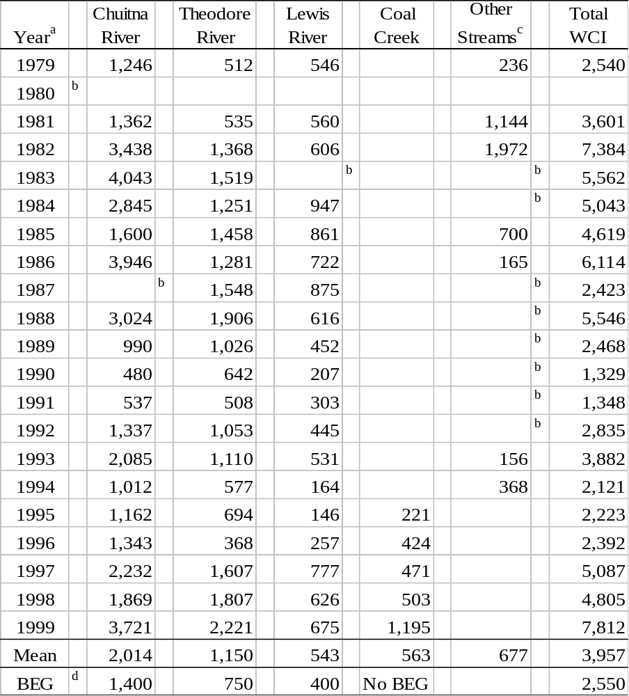
ª Aerial count unless otherwise indicated.
^{b} No count conducted, turbid water.
^{c} May include Olsen, Nikoli, Coal, Straight, Bishop, Drill, and Scarp creeks.
^{d} Sustainable escapement goal.
Table 33.-Northern Cook Inlet Management Area recreational harvest of coho salmon by management unit as estimated by SWHS, 1977-2001.
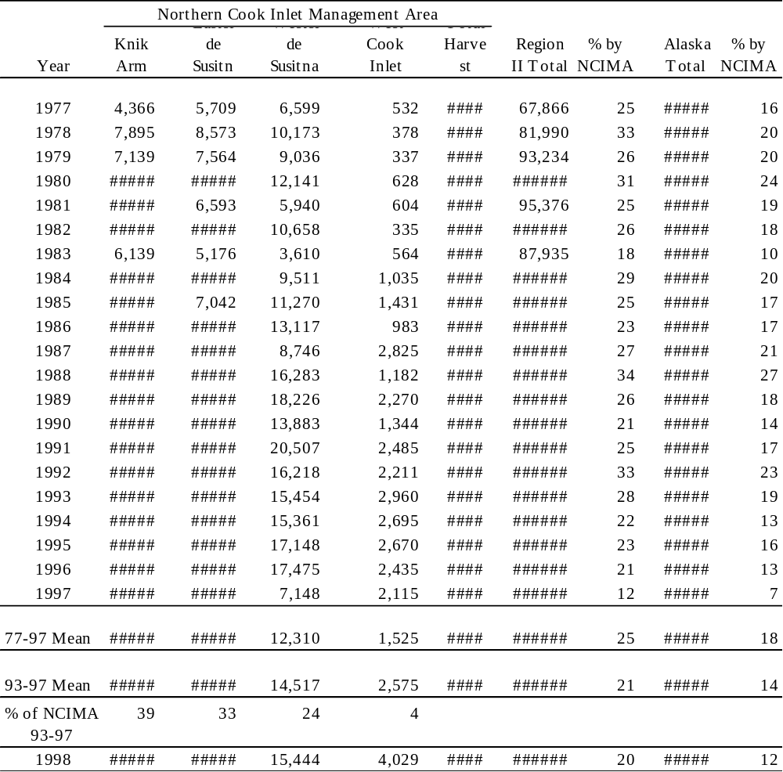

Table 34.-Harvest and effort for Little Susitna River coho salmon as estimated by SWHS, 1977-2001.

ª Participation directed at coho salmon represents only a portion of the annual effort.
^{b} Bartlett and Conrad 1988, Bartlett and Vincent-Lang 1989, Bartlett and Sonnichsen 1990, Bartlett and Bingham 1991, Bartlett 1992-1994, 1996.
^{c} SWHS 1977-2001.

Table 35.-Knik Arm drainage coho salmon escapement index counts, 1981-2002.

ª Foot surveys unless otherwise noted.
^{b} Foot and aerial surveys 1981-1985 and 1987. Weir counts from weir at River Mile 34, 1986, 1988-1995; RM 71, 1996-2000.
^{c} 1982-1991 weir count plus stream survey; 1992, 1993 weir count; 1994-1996 weir was removed on August 15 before the majority of the coho run. In 1997 the weir was out on September 1; in 1998 it was out September 27; in 1999 it was out September 26.
^{d} No survey conducted.
^{e} Weir washed out in flood from July 21-July 29, 1986.
^{f} Count conducted late due to high water.
^{g} Grand total includes Little Susitna total, Fish Creek weir, Cottonwood Creek survey, Wasilla Creek survey total, Yellow Creek, McRoberts Creek/Jim Creek total and Eklutna Tailrace.
^{h} Combination weir and foot survey. Weir was removed prior to completion of coho run.
^{i} Beginning in 1999 highest count of three counts in a two week period.
Table 36.-Coho salmon stocking history for the Little Susitna River, 1982-1996.
 | Fingerling Release |  |  |  | Smolt Release |  |  | Total |  | Number
Year | Size | Number | Number |  | Size | Number | Number | Number | Recovery | Recovered | % of
Stocked | (gm) | Released | Marked |  | (gm) | Released | Marked | Released | Year | in Harvest | Harvestª
1982 | 0.57 | 2,950 |  |  |  |  |  | 2,950
1983 | 0.57 | 216,508 | 20,835 |  |  |  |  | 216,508
1984 | 0.91 | 426,216 | 10,000 |  |  |  |  | 426,216
1985 | 0.30 | 1,225,000 | 10,004 |  | 17.1 | 54,394 | 12,151 | 1,279,394
1986 | 1.00 | 316,270 |  |  | 17.2 | 580,065 | 24,401 | 580,065 | 1986 | 109 | 18
1987 |  |  |  |  | 19.2 | 301,167 | 24,650 | 301,167 | 1987 | 3,407 | 26
1988 | 1.00 | 3,374,126 | 3,126 |  | 20.1 | 446,016 | 24,628 | 3,820,142 | 1988 | 9,638 | 51
1989 |  |  |  |  | 19.8 | 354,897 | 25,631 | 354,897 | 1989 | 10,597 | 75
1990 | 1.1-2.0 | 473,327 | 72,327 |  | 20.8 | 308,356 | 45,220 | 781,683 | 1990 | 2,242 | 30
1991 |  |  |  |  | 22.2 | 277,762 | 46,358 | 277,762 | 1991 | 7,699 | 47
1992 |  |  |  |  | 23.8 | 312,925 | 38,786 | 312,925 | 1992 | 3,406 | 17
1993 |  |  |  |  | 19.0 | 279,873 | 40,242 | 279,873 | 1993 | 7,703 | 28
1994 |  |  |  |  | 19.7 | 126,694 | 43,818 | 126,694 | 1994 | 6,165 | 35
1995 |  |  |  |  | 21.3 | 151,985 | 45,245 | 151,985 | 1995 | 2,991 | 21
1996 |  |  |  |  |  |  |  | 0 | 1996 | 3,418 | 23
Mean |  |  |  |  |  |  |  |  |  | 5,215 | 34
ª Bartlett and Conrad 1988, Bartlett and Vincent-Lang 1989, Bartlett and Sonnichsen 1990, Bartlett and Bingham 1991, Bartlett 1992-1994, 1996.
Table 37.-Sex and age composition and length-at-age of coho salmon sampled from the Little Susitna River, Deshka River, Cottonwood Creek, Fish Creek and Wasilla Creek weirs, 2001 and 2002.

**find in AgeComp.xls**-- Table 37a and 37b
Table 38.-Fishing effort and coho salmon harvest from Knik Arm fisheries as estimated by SWHS, 1977-2001.
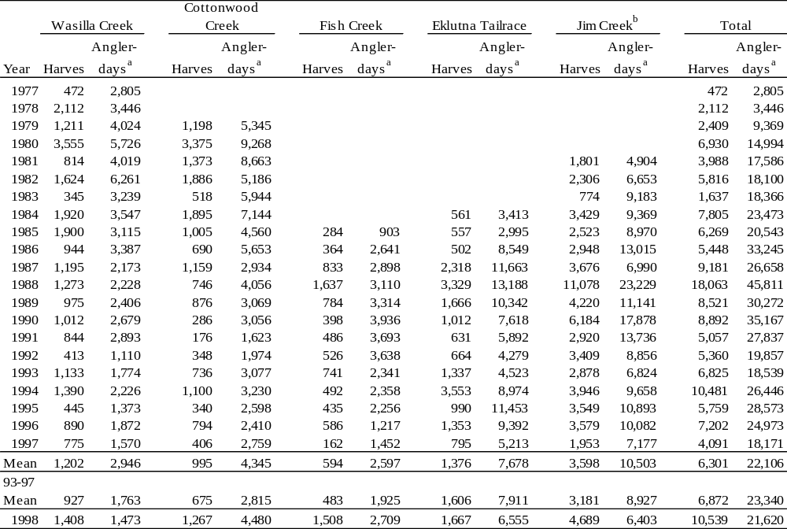
92
ª Participation includes effort directed at species other than coho salmon.
^{b} Knik River and tributaries including Jim Creek.

Table 39.-Summary of coho salmon stocked in Cottonwood, Wasilla, Jim, and Fish creeks and the Eklutna tailrace, 1977-2002.
 |  | Release |  | Average | Number | Number
Brood Year | Brood Stock | Year | Drainage | Size (g) | Released | Marked
Big Lake Hatchery
1977 | Big Lake | 1978 | Cottonwood Creek | 0.80 | 317,694 | 32,064
1978 | Big Lake | 1979 | Cottonwood Creek | 0.54 | 246,762 | 19,992
1979 | Big Lake | 1980 | Cottonwood Creek | 0.63 | 154,991 | 15,000
1979 | Big Lake | 1980 | Cottonwood Creek | 0.49 | 155,004 | 15,000
1980 | Big Lake | 1981 | Cottonwood Creek | 0.59 | 299,742 | 30,528
1981 | Big Lake | 1982 | Cottonwood Creek | 0.45 | 364,911 | 89,389
1982 | Cottonwood Lk | 1983 | Cottonwood Creek | 0.45 | 368,022 | 23,465
 | & Big Lake
1983 | Cottonwood Lk | 1984 | Cottonwood Creek | 0.91 | 372,318 | 10,373
 | Big Lake
1984 | Cottonwood Lk | 1985 | Cottonwood Creek | 0.30 | 317,000 | 10,000
 | & Big Lake
1985 | Big Lake | 1986 | Cottonwood Creek | 0.85 | 315,881 | 13,092
1986 | Big Lake | 1987 | Cottonwood Creek | 1.4 | 315,916 | 15,600
1987 | Big Lake | 1988 | Cottonwood Creek | 1.1 | 597,000 | 0
1987 | Big Lake | 1989 | Cottonwood Creek | 16.4 | 16,900 | 0
1989 | Big Lake | 1990 | Cottonwood Creek | 1.1 | 202,000 | 0
1989 | Big Lake | 1991 | Cottonwood Creek | 25.3 | 72,000 | 0
1990 | Big Lake | 1992 | Cottonwood Creek | 11.0 | 53,900 | 35,341
1991 | Big Lake | 1993 | Cottonwood Creek | 12.1 | 74,198 | 40,875
1986 | Big Lake | 1988 | Wasilla Creek | 17.0 | 12,850 | 0
1987 | Big Lake | 1989 | Wasilla Creek | 15.7 | 21,600 | 0
1989 | Big Lake | 1990 | Wasilla Creek | 1.1 | 152,000 | 0
1989 | Big Lake | 1991 | Wasilla Creek | 25.0 | 69,500 | 0
1990 | Big Lake | 1992 | Wasilla Creek | 10.9 | 76,315 | 44,148
1991 | Big Lake | 1993 | Wasilla Creek | 11.4 | 77,174 | 41,711
1986 | Big Lake | 1988 | Jim Creek | 17.0 | 7,550 | 0
1987 | Big Lake | 1989 | Jim Creek | 16.4 | 20,100 | 0
1989 | Big Lake | 1990 | Jim Creek | 1.1 | 163,000 | 0
1976 | Big Lake | 1977 | Fish Creek | 0.28 | 40,673 | 0
1977 | Big Lake | 1978 | Fish Creek | 0.70 | 101,081 | 40,959
1978 | Big Lake | 1979 | Fish Creek | 0.49 | 383,295 | 30,218
1979 | Big Lake | 1980 | Fish Creek | 0.58 | 450,827 | 22,337
1980 | Big Lake | 1981 | Fish Creek | 0.64 | 118,071 | 13,072
1981 | Big Lake | 1982 | Fish Creek | 0.45 | 596,975 | 23,735
1982 | Big Lake | 1983 | Fish Creek | 0.45 | 1,379,179 | 24,329
1983 | Big Lake | 1984 | Fish Creek | 0.76 | 987,166 | 11,166
-continued-
Table 39.-Page 2 of 2.
 |  | Release |  |  |  |  |  |  |  | Average |  |  |  |  |  | Number |  |  |  |  |  | Number
Brood Year | Brood Stock | Year |  |  | Drainage |  |  |  | Size (g) |  |  |  |  |  | Released |  |  |  |  |  | Marked
1984 | Big Lake | 1985 |  |  | Fish Creek |  |  |  |  | 0.30 |  |  |  |  |  | 1,641,600 |  |  |  |  |  | 10,000
1985 | Big Lake | 1986 |  |  | Fish Creek |  |  |  |  | 1.0 |  |  |  |  |  | 2,354,725 |  |  |  |  |  | 13,497
1986 | Big Lake | 1987 |  |  | Fish Creek |  |  |  |  | 1.2 |  |  |  |  |  | 1,906,945 |  |  |  |  |  | 15,632
1986 | Big Lake | 1987 |  |  | Fish Creek |  |  |  |  | 7.8 |  |  |  |  |  | 445,310 |  |  |  |  |  | 20,010
1986 | Big Lake | 1988 |  |  | Fish Creek |  |  |  |  | 17.0 |  |  |  |  |  | 20,400 |  |  |  |  |  | 20,400
1987 | Big Lake | 1988 |  |  | Fish Creek |  |  |  |  | 1.2 |  |  |  |  |  | 1,562,850 |  |  |  |  |  | 14,050
1987 | Big Lake | 1988 |  |  | Fish Creek |  |  |  |  | 7.6 |  |  |  |  |  | 366,226 |  |  |  |  |  | 21,384
1987 | Big Lake | 1989 |  |  | Fish Creek |  |  |  |  | 15.7 |  |  |  |  |  | 10,644 |  |  |  |  |  | 9,644
1988 | Big Lake | 1990 |  |  | Fish Creek |  |  |  |  | 19.0 |  |  |  |  |  | 21,671 |  |  |  |  |  | 5,671
1989 | Big Lake | 1990 |  |  | Fish Creek |  |  |  |  | 1.2 |  |  |  |  |  | 504,077 |  |  |  |  |  | 20,077
1989 | Big Lake | 1991 |  |  | Fish Creek |  |  |  |  | 25.3 |  |  |  |  |  | 82,988 |  |  |  |  |  | 9,488
1990 | Big Lake | 1992 |  |  | Fish Creek |  |  |  |  | 10.9 |  |  |  |  |  | 74,953 |  |  |  |  |  | 45,538
1991 | Big Lake | 1993 |  |  | Fish Creek |  |  |  |  | 10.8 |  |  |  |  |  | 67,934 |  |  |  |  |  | 43,257
Eklutna Hatchery
1981 | Cottonwood Lk | 1983 |  |  | Tailrace |  |  |  |  | 15.4 |  |  |  |  |  | 633ª |  |  |  |  |  | 452
 | & Big Lake
1982 | Cottonwood Lk | 1984 |  |  | Cottonwood Creek |  |  |  |  | 18.7 |  |  |  |  |  | 16,244 |  |  |  |  |  | 15,757
 | & Big Lake
1982 | Cottonwood Lk | 1984 |  |  | Tailrace |  |  |  |  | 18.7 |  |  |  |  |  | 28,150ª |  |  |  |  |  | 27,306
 | & Big Lake
1984 | Cottonwood Lk | 1986 |  |  | Tailrace |  |  |  |  | 22.0 |  |  |  |  |  | 101,326 |  |  |  |  |  | 101,326
 | & Big Lake
1985 | Eklutna | 1987 |  |  | Tailrace |  |  |  |  | 25.0 |  |  |  |  |  | 147,715 |  |  |  |  |  | 14,772
1986 | Eklutna | 1988 |  |  | Tailrace |  |  |  |  | 16.0 |  |  |  |  |  | 72,881 |  |  |  |  |  | 7,300
1987 | Eklutna | 1988 |  |  | Jim Creek |  |  |  |  | 1.4 |  |  |  |  |  | 68,000 |  |  |  |  |  | 0
1987 | Eklutna | 1989 |  |  | Tailrace |  |  |  |  | 19.0 |  |  |  |  |  | 50,787 |  |  |  |  |  | 2,052
1988 | Eklutna | 1990 |  |  | Tailrace |  |  |  |  | 21.6 |  |  |  |  |  | 54,278 |  |  |  |  |  | 2,916
1989 | Eklutna | 1991 |  |  | Tailrace |  |  |  |  | 22.0 |  |  |  |  |  | 21,285 |  |  |  |  |  | 1,381
1990 | Eklutna | 1992 |  |  | Tailrace |  |  |  |  | 16.7 |  |  |  |  |  | 131,829 |  |  |  |  |  | 0
1991 | Eklutna | 1993 |  |  | Tailrace |  |  |  |  | 15.9 |  |  |  |  |  | 108,000 |  |  |  |  |  | 0
1992 | Eklutna | 1994 |  |  | Tailrace |  |  |  |  | 11.5 |  |  |  |  |  | 62,400 |  |  |  |  |  | 0
1993 | Eklutna | 1995 |  |  | Tailrace |  |  |  |  | 16.9 |  |  |  |  |  | 69,867 |  |  |  |  |  | 0
1994 | Eklutna | 1996 |  |  | Tailrace |  |  |  |  | 14.5 |  |  |  |  |  | 69,176 |  |  |  |  |  | 0
1995 | Eklutna | 1997 |  |  | Tailrace |  |  |  |  | 14.5 |  |  |  |  |  | 69,475 |  |  |  |  |  | 0
1996 | Eklutna | 1998 |  |  | Tailrace |  |  |  |  | no data |  |  |  |  |  | 105,000 |  |  |  |  |  | 0
Elmendorf Hatchery
1994 | Little Susitna R. | 1996 |  |  | Wasilla Creek |  |  |  |  |  | 20.9 |  |  |  |  |  | 145,923 |  |  |  |  |  | 46,839
Fort Richardson Hatchery
1996 | Jim Creek | 1998 |  |  | Eklutna Tailrace |  |  |  |  |  | 17.9 |  |  |  |  |  | 112,219 |  |  |  |  |  | 111,882
1997 | Jim Creek | 1999 |  |  | Eklutna Tailrace |  |  |  |  |  | 16.6 |  |  |  |  |  | 126,602 |  |  |  |  |  | 42,663
1998 | Jim Creek | 2000 |  |  | Eklutna Tailrace |  |  |  |  |  | 19.7 |  |  |  |  |  | 76,851 |  |  |  |  |  | 40,514
1999 | Eklutna | 2001 |  |  | Eklutna Tailrace |  |  |  |  |  | 22.8 |  |  |  |  |  | 124,838 |  |  |  |  |  | 43,713
2000 | Eklutna | 2002 |  |  | Eklutna Tailrace |  |  |  |  |  | 18.7 |  |  |  |  |  | 120,629 |  |  |  |  |  | 44,518
ª Some fingerlings escaped into tailrace due to vandalism.
Table 40.-Fish Creek salmon harvests, by commercial set gillnet and personal use dip net, 1987-2002.
**table 40 in Harvest03.xls file**
ª Mills 1988-1994, Howe et al. 1995, 1996, 2001a. 1998-2001 are estimated from returned permits.
Table 41.-Coho salmon sustainable escapement goals (SEG) for Knik Arm Management Unit streams.
Stream | Sustainable Escapement Goal (SEG)
Cottonwood Creek (weir) | 800-2,200
Wasilla Creek (weir) | No goal
Fish Creek (weir) | 1,200-4,400
Jim Creek Drainage (foot survey) | 450-700
Little Susitna River (weir) | 10,100-17,700
Originally set as Biological Escapement Goals (BEG) then converted to SEG in 2002.

Table 42.-Eastside and westside Susitna River drainage coho salmon escapement index counts, 1981-2002.
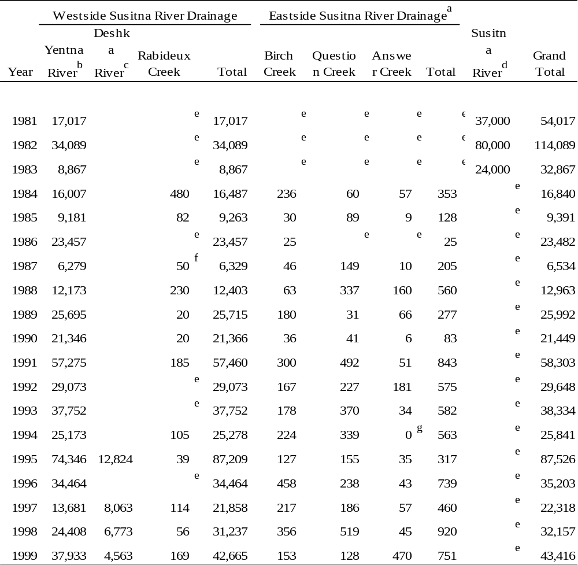
ª Survey conducted by walking portions of the creek.
^{b} Sonar counts, dates of assessment vary; estimates for 1981-1984 encompass the entire coho salmon migration.
^{c} Weir count. 1995 RM 17, 1997-1999 RM 7: 1998 and 1999 weirs were underwater for an extended time during coho season resulting in an incomplete count.
^{d} Sonar counts upstream of River Mile 80.
^{e} No survey conducted.
^{f} Poor survey conditions.
^{g} Beaver dam downstream of index area blocking passage of fish.
Table 43.-Harvest and effort for the Kustatan River coho salmon sport fishery, 1984-2001.

ª Effort directed toward all species.
Table 44.-Bodenburg Creek escapement index surveys, 1968-2002.

Table 45.-Sockeye salmon counts from Yentna River sonar, Chelatna, Hewitt, Judd and Larson lakes, Fish, Cottonwood, Jim and Packers creeks weirs, and Little Susitna River weir, 1968-2002.

ª Bartlett Unpublished b and c.
^{b} Measured by weir (1968 excepted). Years 1980-1993 include downstream foot surveys upon removing weir.
^{c} Years hatchery sockeye salmon contributed to the escapement were 1979-1981, 1983-1999.
^{d} Bartlett and Vincent-Lang 1989; Bartlett and Sonnichsen 1990; Bartlett 1996a and 1996b.
^{e} CIAA 1991.
^{f} CIAA 1998a.
^{g} CIAA 1998b.
^{h} A counting screen was used instead of a weir.
^{i} The mean coho salmon escapement is not estimated because in many years of record the weir was removed before the run was complete.
Table 46.-Big Lake Hatchery (1975-1992), Eklutna Hatchery (1993-1996) and Trail Lakes Hatchery (1997-2002) sockeye salmon fry releases into the Big Lake drainage by brood year, 1975-2002.
Brood Year | Eggs Incubated | Fry Released | Egg/Fry Survival | Number Marked | Release Size-gm | Smolt Released |  | Release Size-gm
1975 | 180,300 | 71,168 | 39.5% | 0 | 0.15
1976 | 10,034,013 | 7,686,382 | 76.6% | 72,673 | 0.15
1977 | 8,748,867 | 5,739,010 | 65.6% | 66,153 | 0.13
1978 | 9,832,726 | 0 | 0.0%
1979 | 5,053,808 | 806,047 | 15.9% | 0 | 0.15
1980 | 4,699,733 | 3,967,941 | 84.4% | 0 | 0.14
1981 | 5,662,004 | 4,263,356 | 75.3% | 0 | 0.17
1982 | 8,624,662 | 6,601,409 | 76.5% | 0 | 0.16
1983 | 9,294,426 | 7,362,000 | 79.2% | 0 | 0.15
1984 | 16,210,000 | 12,430,000 | 76.7% | 18,835 | 0.15
1985 | 21,550,000 | 15,000,000 | 69.6% | 18,120 | 0.20
1986 | 17,500,000 | 11,866,000 | 67.8% | 19,613 | 0.20
1987 | 20,300,000 | 14,492,000 | 71.4% | 20,085 | 0.15
1988 | 19,700,000 | 13,205,848 | 67.0% | 24,848 | 0.15
1989 | 14,835,000 | 10,815,319 | 72.9% | 24,319 | 0.20
1990 | 14,734,000 | 10,037,290 | 68.1% | 22,290 | 0.24
1991 | 7,357,000 | 3,111,000 | 56.4% | 0 | 0.25
1992 | 10,330,000 | 4,586,000 | 59.2%ª | 0 | 0.22
1993 | 9,000,000 | 5,000,000 ^{b} | 91.8% | 0 | 0.43
1994 | 7,700,000 | 5,000,000 ^{b} | 80.5% | 0 | 0.40
1995 | 8,000,000 | 5,000,000 ^{b} | 81.6% | 0 | 0.39
1996 | 8,000,000 | 4,000,000 ^{b} | 66.9% | 0 | 0.40
1997 | 8,000,000 | 5,000,000 ^{b} | 62.5% | 0 | no data
1998 | 5,132,000 | 197,000^{b} | 20.3% | 100% ^{c} | 0.62-0.73
1999 | 1,490,000 | 845,800 | 56.8% | 100% ^{c} | 0.30-0.41
2000 | 3,638,000 | 0 | 70.4% | 100% ^{c} | NA
2001 | 6,286,000 | 4,316,000 | 73.1% | 100% ^{c} | 0.51-0.57
2002 | 6,342,000 |  |  | 100% ^{c}
ª Includes 1,534,000 fry transferred to Eklutna hatchery.
^{b} Additional fry retained for smolt program.
^{c} 100% otolith marked.
Table 47.-Educational fishery permit harvests in NCIMA, 1994-2002.
Permit Holder |  | Chinook | Coho | Sockeye | Pink | Chum | Total | Dates of Operation
Knik Tribal Council
1994 |  |  |  |  |  |  | 29
1995 |  | 5 | 1 | 21 | 0 | 1 | 28
1996 |  | 5 | 45 | 163 | 3 | 62 | 278 | 6/17-7/20
1997 |  | 19 | 34 | 153 | 0 | 15 | 221 | 5/29-8/10
1998 |  | 31 | 153 | 186 | 0 | 85 | 455 | 5/14-8/15
1999 |  | 42 | 120 | 177 | 0 | 55 | 394 | 5/27-8/14
2000 |  | 65 | 63 | 34 | 0 | 18 | 180 | 5/26-8/06
2001 |  | 32 | 34 | 71 | 0 | 0 | 137 | 5/13-8/10
Average |  | 28 | 64 | 115 | 1 | 34 | 215
2002 |  | 55 | 99 | 136 | 5 | 36 | 331 | 5/20-8/9
Eklutna Village
1994 |  |  | 7 |  |  |  | 172
1995 |  | 14 | 37 | 55 | 6 | 42 | 155
1996ª
1997 |  | 7 | 14 | 39 | 16 | 7 | 83 | 5/1-9/30
1998 |  | 32 | 116 | 104 | 6 | 51 | 309 | 5/1-9/30
1999 |  | 11 | 25 | 80 | 3 | 20 | 139 | 5/1-9/30
2000 |  | 17 | 85 | 76 | 21 | 51 | 250 | 5/1-9/30
2001 |  | 58 | 95 | 52 | 56 | 34 | 295 | 5/1-9/30
Average |  | 23 | 54 | 68 | 18 | 34 | 200
2002 |  | 58 | 156 | 220 | 40 | 76 | 550 | 5/1-9/30
Tyonek Village
1998 |  | 0 | 41 | 11 | 3 | 1 | 56 | 8/12-8/14
1999 |  | 0 | 0 | 100 | 0 | 0 | 100 | 7/7-7/10
2000 |  | 0 | 0 | 97 | 0 | 0 | 97 | 7/6-7/9
Average |  | 0 | 14 | 69 | 1 | 1 | 84
ª No data available
Table 48.-Northern Cook Inlet Management Area lake stocking summary for nonanadromous fish, 2001 and 2002.
-continued-
Table 48.-Page 2 of 4.
-continued-

Table 48.-Page 3 of 4.
-continued-
Table 48.-Page 4 of 4.

ª Treatment: AF = diploid all-female; TAF = triploid all-female.
^{b} Stocking Method: T = tank truck; T/BU = carried in buckets to lake; T/4W = transported by 4-wheeler

Table 49.-Statewide Harvest Survey estimated harvest and catch for NCIMA stocked lakes, 2000 and 2001.
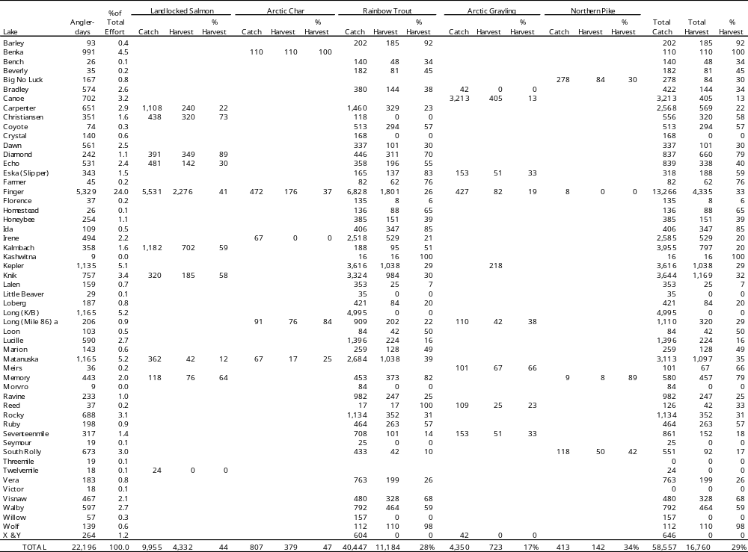
121
ª Lake trout were also stocked in Long Lake in 1996. Nine lake trout were caught and harvested in 1997.
Table 50.-Northern Cook Inlet Management Area recreational catch and harvest of rainbow trout by management unit as estimated by SWHS, 1977-2001.
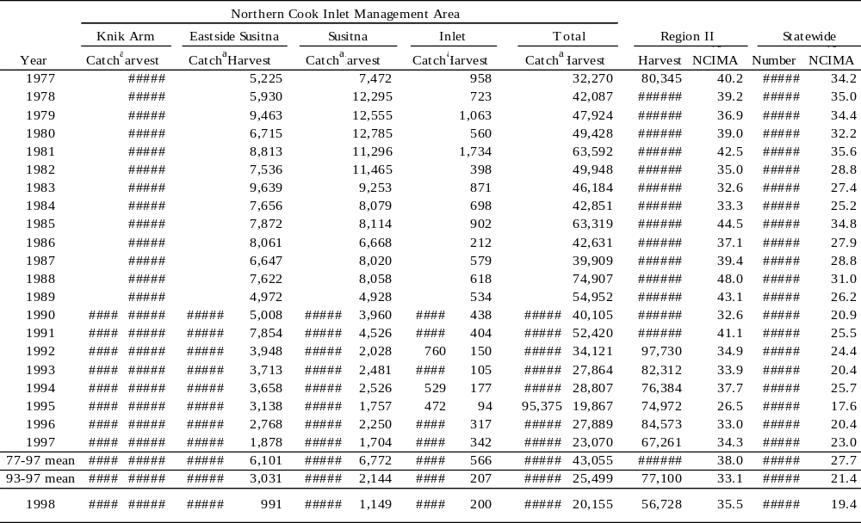
122
From: Mills 1979-1994, Howe et al. 1995-1999
ª Catch estimates available beginning in 1990.
Table 51.-Northern Cook Inlet Management Area recreational catch and harvest of northern pike by management unit as estimated by SWHS, 1977-2001.
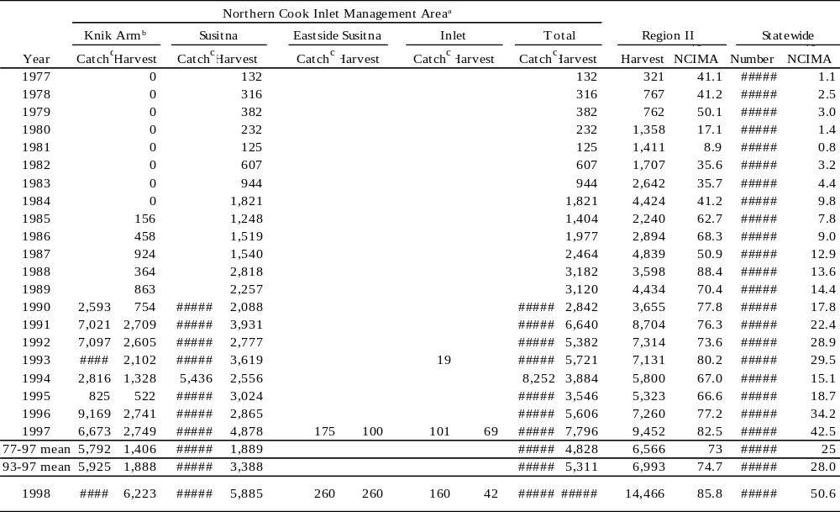
130
ª No reported catch or harvest from Eastside Susitna or West Cook Inlet management units until 1993.
^{b} Harvest of northern pike prior to 1985 may have been included in other fish species category.
^{c} Catch estimates available beginning in 1990.

